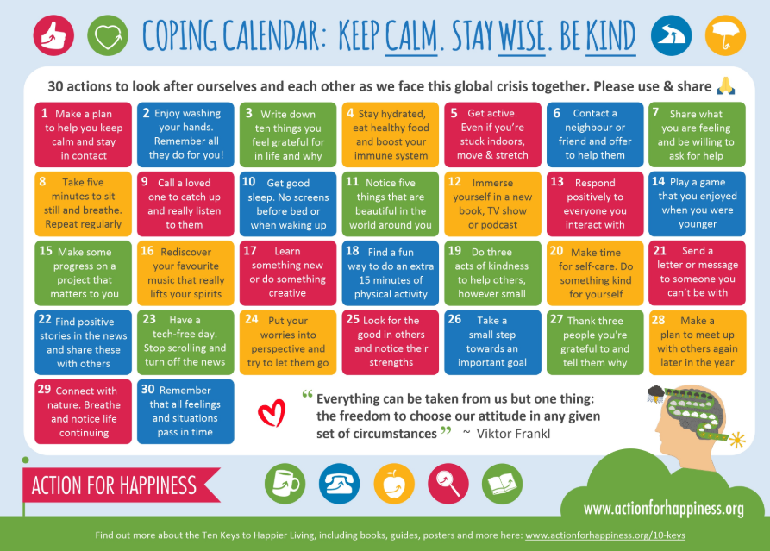
Friday 27th march 2020

Dear Parents and Carers,
CORONAVIRUS UPDATE 5
Thank you so much for your support during this very difficult and trying time. As we all try to adjust to this new ‘norm’ we need to be patient and understanding whilst our key workers are saving lives or keeping us safe or the economy working. We are only open for Keyworker children who are not working from home or vulnerable children #StayAtHomeSavesLives.
As I explained in my letter when we had to close early (reduced staffing, no caretaker & family members who had had direct contact with those tested positive for COVID19), we paused the curriculum in school. This was because we recognised that any new learning taking place would be impossible to plan, track or assess as our pupil numbers diminished this proved to be a wise choice.
The decision to send an exercise book home with a range of activities or links, was not for it to be completed as quickly as possible, but for the children to take time to become familiar with their new routine. The other reason for not overwhelming families was that we recognised many parents were now being asked to work from home, plus care for children, but also families may be suffering from the virus being ill or having to self isolate. We have some members of our school community who are having to self isolate for 12 weeks, so I and the school team do not want to be dictating timetables, work completion, routines.
But this is a marathon not a sprint, so please…
Some of our children are just as scared as we are right now. Our children not only can hear everything that is going on around the, but they also feel tension and anxiety. None of us have ever experienced anything like this before. Although the idea of being off school for weeks sounds awesome, they are probably picturing it being like a summer break ( the weather is making it feel like it with all this sun), but eventually the reality of not being able to play out with friends or see friend at school will hit them hard.
Over the coming weeks, you may see a change in some behaviour with your children. Whether it’s anxiety, or anger, or protest that they can’t do things normally – it will happen. You may even see meltdowns, tantrums and oppositional behaviour in the coming weeks. This is normal and expected under these circumstances. If you are concerned or need advice please email Mrs Quigg or Mrs Ryder: Aquigg@stthomasmorerc.rochdale.sch.uk and vryder@stthomasmorerc.rochdale.sch.uk
What our children need right now is to feel comforted and loved, to feel like it’s all going to be ok. Get them in the garden and enjoy the sun, go for your daily exercise as recommended by the Prime Minister, let them draw and paint pictures, play board games, watch movies, bake or cook, do virtual field trips, start a book and read together or snuggle under warm blankets and do nothing on occasion.
Don’t worry about them regressing in school. Every single child is in this boat and they will all be alright. When we are back in the classroom, we will all work hard and meet their needs where they are. Teachers are experts at this!

Please don’t get upset or into arguments with your children because they don’t want to do extra maths. We are constantly Tweeting or adding to the website www.stthomasmore.co.uk links to activities for them to do e.g. Twinkl have this www.Twinkl.co.uk/offer need to put your email address in, create a password and then the code: PARENTSTWINKLHELPS , none of the activities we are sending links to are mandatory.
Staff Email addresses to be used only school hours 7:45am – 4pm:  sdodd@stthomasmorerc.rochdale.sch.uk  DHughes@stthomasmorerc.rochdale.sch.uk  HChurchman@stthomasmorerc.rochdale.sch.uk  ccraven@stthomasmorerc.rochdale.sch.uk  BAHickman@stthomasmorerc.rochdale.sch.uk  DMcBride@stthomasmorerc.rochdale.sch.uk  KSchrecker@stthomasmorerc.rochdale.sch.uk  JJones@stthomasmorerc.rochdale.sch.uk  aweekes@stthomasmorerc.rochdale.sch.uk  CEBarran@stthomasmorerc.rochdale.sch.uk  BBanim@stthomasmorerc.rochdale.sch.uk  LYoung@stthomasmorerc.rochdale.sch.uk  aquigg@stthomasmorerc.rochdale.sch.uk  vryder@stthomasmorerc.rochdale.sch.uk  jbutterworth@stthomasmorerc.rochdale.sch.uk | School Twitter accounts  Mrs Butterworth = @StThomasMoreAlk  Mrs Quigg = @Mrs QuiggSTM  Miss O'Donnell =@MissODonnellSTM  Miss Barran = @MissBarranSTM  Miss Banim = @MissBanimSTM  Miss Jones = @Miss_JonesSTM  Mrs Shrecker (Howcroft) = @MissHowcroftSTM  Miss Weekes = @MrsWeekesSTM  Mrs Craven = @MrsCravenSTM  Miss McBride = @MissMcBrideSTM  Miss Dodd = @MissSDoddSTM  Mrs Hickman = @MrsHickmanSTM  MIss Churchman = @MissChurchmnSTM  Miss Hughes = @MissHughesSTM  St Thomas More Office = @OfficeSTM  St. ThomasMore RC PTA =@PTASTM

The main thing is this…at the end of all this, your child’s mental wellbeing and health will be more important than their academic skills. How they felt at this time will stay with them long after the memory of what they did during those weeks is long gone so please keep that in mind, every single day.
We will continue to use Text service, Twitter and the Website to update you in this ever changing situation and thank you for your support during this time.
I am sending you all love and best wishes #StaySafe.
Mrs J Butterworth
Headteacher

